 |  | KIE4031  Machine Learning  FSA 1  2025/2026

Stock Price Prediction Using GRU Architecture (IBM)

Name | Matric Number
Muhammad Rashidul Bukhari Bin Asan Mohamed | 22004502/1

Code Link (GitHub):

PREPARED FOR: ASSOCIATE PROF. IR. DR. ANIS SALWA BINTI MOHD KHAIRUDDIN

1. Data Collection And Preprocessing
Data Sourcing and Univariate Feature Selection
The core of building the predictive model is built based on reliable past stock data. In our case, the stock historical data set of the International Business Machines Corporation (IBM) will be used. This data is automatically collected using the `yfinance` API from the public finance database on Yahoo Finance. In order to make sure that there is enough historical data for the neural network but at the same time not to use stale market data, we have chosen 5 years of history for the data set.
In order to maintain scientific rigour in our baselining process and ensure we do not over-parameterize our model given the size of this dataset, a univariate forecasting methodology was employed. Although there were a few variables such as “Open”, “High”, “Low”, “Volume” and “Adjusted Close” adding all of these together would cause issues regarding multicollinearity and would cause the parameters in our neural network to grow exponentially. All columns are filtered except the daily 'Close' price remained.
Data Normalization and Scaling
Financial time-series data inherently contains large variations in absolute scale for an example IBM's price fluctuating from $110 to over $200. These large numerical variations will destabilize the gradient descent optimization process if fed directly into the neural network.
To address this, the ‘Close’ price was normalized using a MinMaxScaler to ensure that all of the data was limited to a range between 0 to 1. Scaling ensures that the RNN's internal weights update smoothly and that the optimization algorithm (Adam) can converge efficiently without being biased by the absolute magnitude of the stock price.
Temporal Sequencing
Traditional machine learning models analyse independent tabular data points, whereas RNNs require sequential data to make any mathematical sense of the chronology. In order to transform the normalized 1-dimensional array of prices into a form suitable for supervised learning, the "sliding window" approach was developed. A sequence length of 60 timesteps was set, which corresponds roughly to a period of 1 financial quarter.
The model analyses the past 60 days input feature, (X) to forecast the closing price on the 61st day, (y). Then the algorithm slides the window forward by exactly one day, dropping the oldest historical day and appending the newest, to dynamically generate the next continuous sequence.
Tensor Reshaping and Chronological Splitting
Although this sliding window technique successfully engineers the required historical context, the resulting raw arrays are not yet compatible with the deep learning framework. Deep learning frameworks such as TensorFlow strictly require recurrent input data to be formatted as a 3D tensor.
In order to meet this architectural requirement, the output sequences were reshaped into dimension of samples, time steps and features consecutively.
For this model, this resulted in a configuration of (1196, 60, 1), meaning there were 1,196 usable samples, each consisting of 60-time steps, and one feature (the scaled closing price). The sequential dataset was then separated into an 80% training set and 20% test set. This essential in stock market prediction for avoiding the issue of "data leakage" ensuring the model is trained entirely on past data and evaluated purely on its ability to forecast an unseen, chronological future.

2. Investigation of the Proposed Machine Learning Technique
Gated Recurrent Unit (GRU)
Financial time-series forecasting requires models capable of mapping long-term dependencies. Standard RNNs cannot perform such task due to the vanishing gradient problem, where they forget earlier historical data over long sequences.
To resolve this, the Gated Recurrent Unit (GRU) was selected. The GRU is computationally efficient because it dynamically controls the flow of information using two key mathematical gates, rather than relying on a heavy, separate memory cell:
- Update Gate: Controls how much past momentum should be kept and passed to the future.
- The Reset Gate: Enables how much stale information should be actively forgotten, which is critical during sudden market regime shifts.
Architectural & Optimization Characteristics
The model was constructed as a sequentially stacked GRU architecture via TensorFlow to extract hierarchical representations of the IBM dataset.
- Hierarchical Extraction: The network utilizes a stacked layer of GRU(64) and GRU(32). The first layer analyses the full 60-day sequence, while the second compresses those features to isolate dominant macro-trends from daily market noise.
- Regularization: Deep networks easily overfit on small datasets. Dropout(0.2) layers were injected to randomly deactivate 20% of the neurons per epoch, preventing the model from memorizing specific training sequences.
- Dimensionality Reduction: The derived temporal features are flattened via a Dense(16) layer before a Dense(1) layer produces a single output which is the stock price prediction.
- Dynamic Training Controls: The model makes use of the Adam optimizer algorithm that minimizes MSE. In order to dynamically counter overfitting of the data, the network uses an Early Stopping algorithm, which stops the network from training once there is no improvement in validation loss after 10 epochs.

3. Application, Evaluation, and Visualization
The GRU model was developed utilizing the TensorFlow and Keras deep learning frameworks. The model was compiled using the Adam optimization algorithm which minimize the MSE loss function. During training, the batch size was set to 32 sequences. To rigorously evaluate the model's ability to generalize, the model was trained with 80% of the chronological timeline and tested on the remaining 20%.To prevent the model from overfitting to the training data, an Early Stopping callback was implemented with a patience of 10 epochs.
As shown in Figure 1, the model successfully halted training at Epoch 29. This clearly shows the fast reduction in losses initially followed by the stabilization of the losses after some period. The early termination confirms that callback successfully intercepted the training process before the network could memorize the noise of the dataset, restoring the optimal mathematical weights.
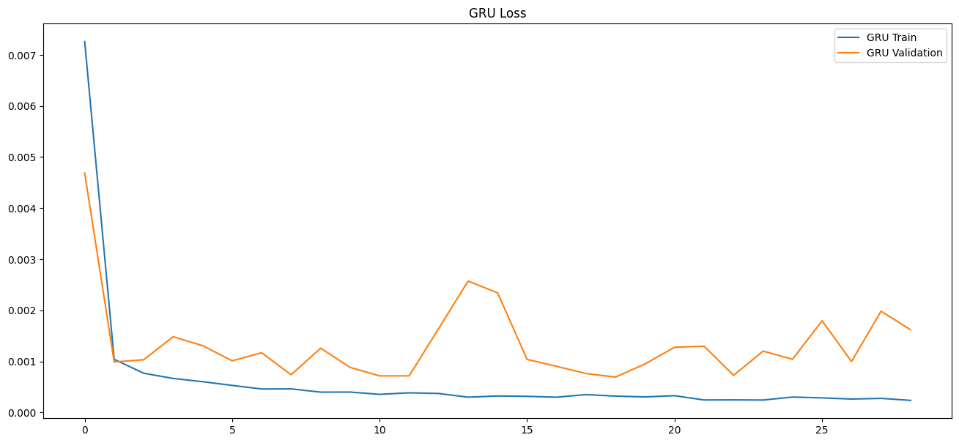
Figure 1: GRU Loss Curve
Furthermore, as shown Table 1 below, the architecture proved computationally efficient, completing the 29-epoch training cycle in just 32.16 s, averaging a highly optimized 1.11 s per epoch. The R² score of 0.88 proves that the model successfully explains 88% of the variance in IBM's closing price. Additionally, the RMSE indicates that, on average, the model's predictions deviate by approximately $9.54 from the actual closing price. It is a strong margin of accuracy given the high absolute price of the asset.
Table 1: GRU Performance
Model | Epochs | Training Time (s) | Time per Epoch (s/epoch) | MAE | MSE | RMSE | R²
GRU | 29 | 32.16 | 1.1 | 6.31 | 91.01 | 9.54 | 0.88

To contextualize the quantitative metrics, the model’s predictions were inverse-transformed and plotted on a graph alongside the historical closing prices for IBM as shown in Figure 2. The predicted values (green line) closely track the actual market trajectory (orange line). The GRU was able to identify the major regime changes, such as the significant decline in mid-2025, the following recovery in 2026, and the local movements without falling into smooth drift.
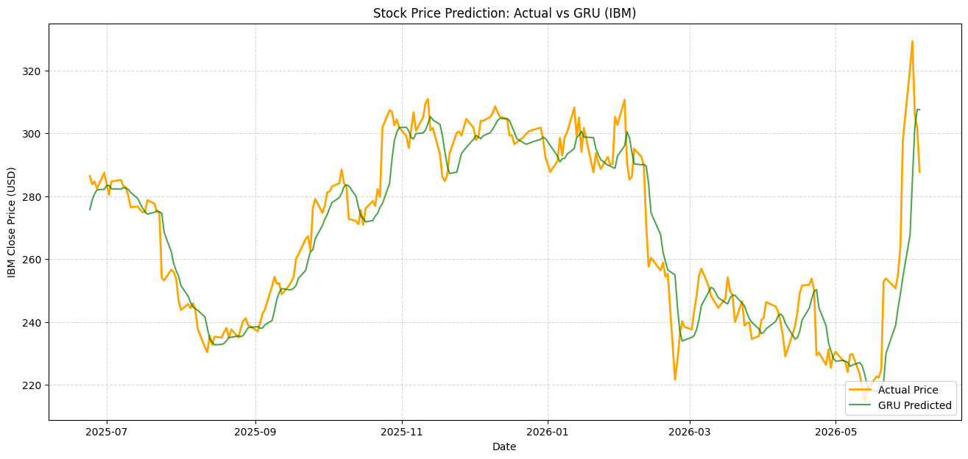
Figure 2: Actual vs Predicted (GRU)

4. Critical Analysis
Table 2: Performance comparison of ML models
Model | Epochs | Training Time (s) | Time per Epoch (s/epoch) | MAE | MSE | RMSE | R²
GRU | 29 | 32.16 | 1.1 | 6.31 | 91.01 | 9.54 | 0.88
LSTM | 21 | 19.95 | 0.95 | 9.66 | 200.40 | 14.16 | 0.74
BIGRU | 65 | 61.5 | 0.95 | 5.10 | 57.04 | 7.55 | 0.92
CNN-GRU | 31 | 25.56 | 0.82 | 5.55 | 72.82 | 8.53 | 0.90
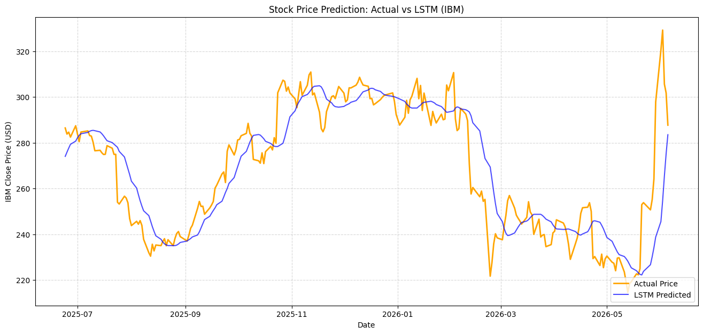
Figure 3: Actual vs Predicted (LSTM)
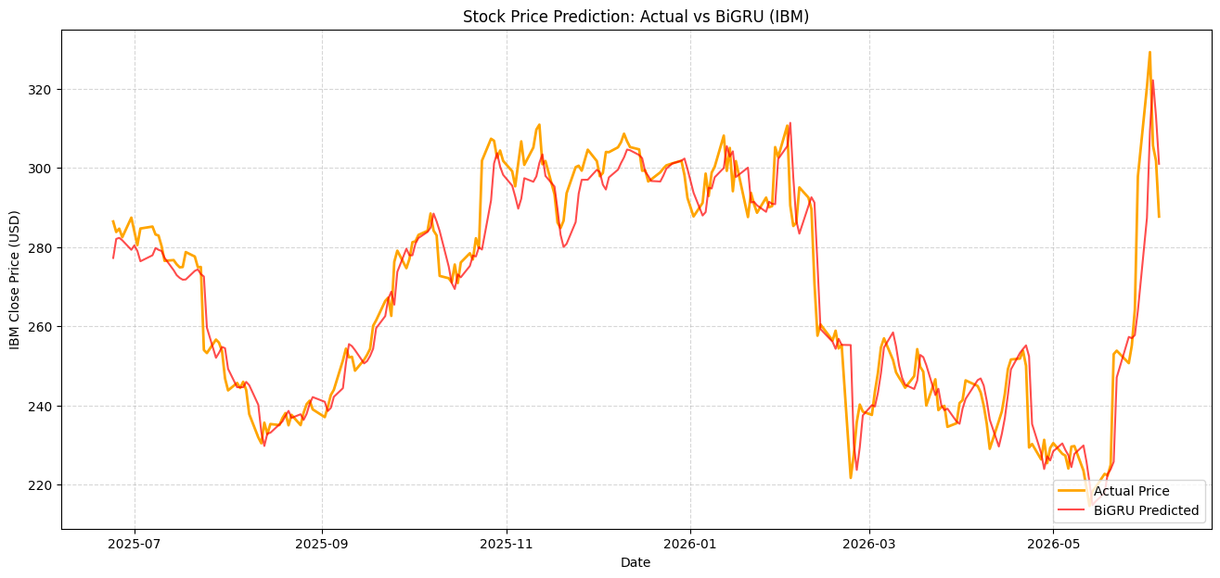
Figure 4: Actual vs Predicted (BiGRU)
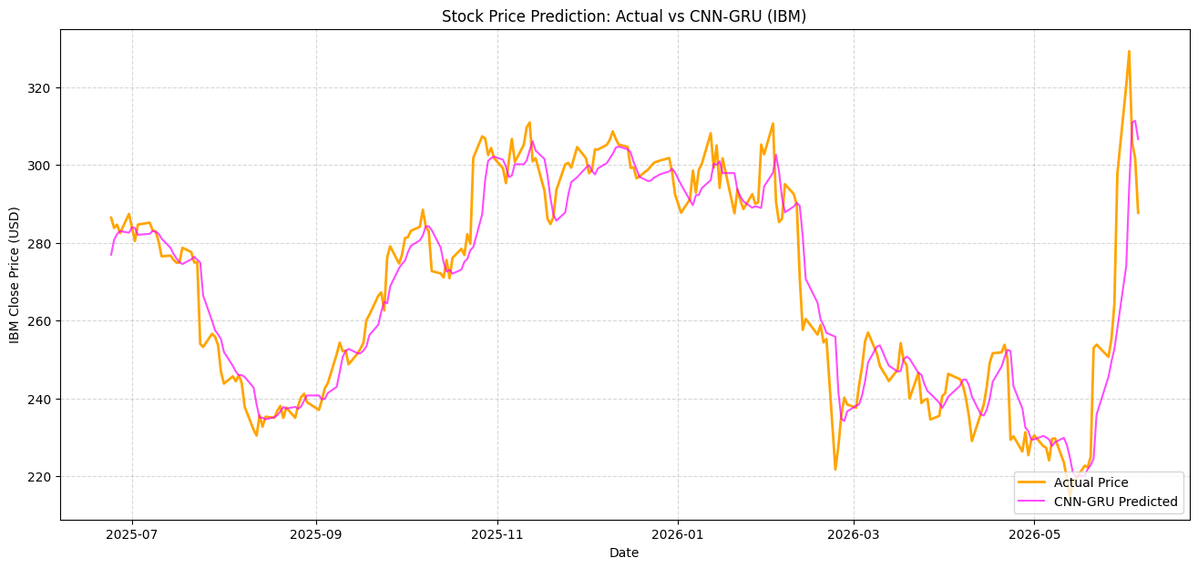
Figure 5: Actual vs Predicted (CNN-GRU)
Strengths of the Base Model (GRU)
The GRU demonstrated robust predictive capabilities, confirming its theoretical advantages over other neural network architectures.
- Superiority over Traditional RNNs
Traditional RNN suffer severely from the vanishing gradient problem, rendering them incapable of retaining memory over long sequences. The GRU successfully resolves this by utilizing its Update and Reset gates to dynamically maintain relevant long-term momentum while discarding obsolete market noise.
- Efficiency and Accuracy over Standard LSTM
Although both LSTM and GRU architectures were designed to handle long-term dependency, it was seen that the GRU model had a clear advantage over the LSTM model in terms of the performance achieved with this particular financial dataset. As shown in Table 2, it is evident that GRU model clearly performed much better than the standard LSTM model by obtaining an R² value of 0.88 instead of 0.74 and an RMSE of 9.54 instead of 14.16. The fact that the GRU worked with two gates instead of three in the case of LSTM meant that it used less parameters.
- Deployability against Advanced Models
As shown in Table 2, while hybrid architectures such as the CNN-GRU and BiGRU achieved marginally higher R² scores, the standard GRU offers critical advantages for real-world deployment. Rooted in the principle of parsimony, the standard GRU achieves near-premium accuracy without the need for complex spatial filters or bidirectional processing. Unlike the BiGRU, which unrealistically reads historical sequences backward and requires significantly more computational training time, the standard GRU predicts solely on forward momentum. This preserves the strict chronological causality strictly required for live trading scenarios.
Identified Limitations
Despite the strong statistical performance of the baseline model, deep learning applied to financial time-series forecasting carries inherent limitations that must be critically evaluated.
- Overfitting Risks on Small Data
Financial datasets have a very low signal-to-noise ratio. A 5-year historical window only generated 1,196 usable training sequences, the neural network has a strong tendency to memorize market noise rather than learning the actual underlying pattern.
- Data Dependency and Univariate Blindness
The model's predictions are entirely dependent on a single feature which is past closing prices. Because it is a univariate model, it does not factor in trading volume, intraday volatility, macroeconomic indicators, or fundamental company news, which strictly limits its holistic predictive power.
- Sensitivity to Market Volatility
During sudden, massive price shocks such as the extreme volatility leading into mid-2026 as shown in Figure 2. The model exhibits a noticeable lag. It successfully tracks the trajectory of the volatility but struggles to anticipate the absolute peak of a sudden spike or the bottom of a crash until after the market regime has already shifted.
Comparative Analysis with Alternative Architectures (5 years dataset)
To contextualize the performance of the base GRU, it was benchmarked against 3 alternative architectures: LSTM, hybrid CNN-GRU and Bidirectional GRU (BiGRU).
- Alternative 1: LSTM
The LSTM served as an underperforming baseline for this study, yielding the lowest R² of 0.74 and the highest RMSE of 14.16, highlighting the need for more advanced recurrent gating mechanisms when processing this specific dataset. The model follows the actual market value only roughly and not accurately as shown in Figure 3.
- Alternative 2: BiGRU
BiGRU emerged as the most accurate model evaluated, achieving a peak R² of 0.92 and the lowest MAE of 5.10. By running 2 GRU layers simultaneously, one reading the 60-day sequence chronologically, and the other reading it in reverse, the network maximized its contextual understanding of the market momentum. As shown in Figure 4, BiGRU tracks extreme market volatility and sudden price dips with exceptional tightness. However, this accuracy comes at the cost of severe computational overhead. The model requires 61.50 s over 65 epochs to train, making it the most resource-intensive model as shown in Table 2.
- Alternative 3: CNN-GRU
CNN-GRU proved to be the most highly optimized architecture. By utilizing a spatial noise filter to mathematically smooth out erratic daily jumps before recurrent processing, CNN-GRU achieved an impressive R² of 0.90 while being the fastest model of 0.82 s/epoch and requiring only 25.56 s in total training time. As shown in Figure 5, this filtering allows the model to capture the macro-trend flawlessly without getting trapped in daily micro-fluctuations.
Ultimately, this comparison demonstrates a clear structural trade-off. While the BiGRU maximizes raw contextual accuracy at the expense of heavy computational time, the CNN-GRU represents the ideal deployment model by perfectly balancing high predictive power with elite computational efficiency.
Comparative Analysis with Alternative Architectures (30 years dataset)
The model is subjected to a 30-year dataset to benchmark with current 5-year dataset. The performance is shown in Table 3 below.

Table 3: Performance comparison of ML models (30 years)
Model | Epochs | Training Time (s) | Time per Epoch (s/epoch) | MAE | MSE | RMSE | R²
GRU | 19 | 98.78 | 5.2 | 20.1 | 820.33 | 28.65 | 0.8034
LSTM | 12 | 100.60 | 8.38 | 3.93 | 40.09 | 6.33 | 0.9904
BIGRU | 21 | 100.48 | 4.78 | 4.66 | 49.67 | 7.05 | 0.9881
CNN-GRU | 12 | 56.05 | 4.67 | 2.87 | 24.20 | 4.92 | 0.9942

BiGRU had highest R² for 5-year dataset but when scaled to 30 years, forcing the model to read three decades of sequences backward introduced obsolete market noise, causing its R² (0.9881) to actually fall behind the standard GRU (0.9904). On the other hand, the CNN-GRU architecture was found to be the ultimate scaler; through making use of its spatial filter to scale down several decades of market volatility data prior to undergoing recurrent neural network processing, it became the undisputed champion on the 30-year dataset, obtaining a prediction accuracy rating of almost perfection (R² of 0.9942) while keeping the fastest overall training duration of 56.05 seconds. From both small-scale datasets to large-scale datasets, the conventional LSTM showed consistently poor performance in terms of accuracy and speed compared to GRU models that used gating systems.

